

LAb Experiments

Name: Huzaifa

Roll NO: 23-Ai-21

Batch: 2023

Department: Artificial Intelligence

Subject: Programming Fundamental

Under the supervision: Muhammad Umer

DATE OF SUBMISSION: 20-12-2023



QUAID-E-AWAM UNIVERSITY OF ENGINEERING, SCIENCE & TECHNOLOGY NAWABSHAH DEPARTMENT OF ARTIFICIAL INTELLIGENCE

PROGRAMMING FUNDAMENTALS

Lab Experiment #02

# OBJECTIVE:

Installation of Python, understanding basic input and output, introduction with data types

# TOOLS REQUIRED:

Personal computer with internet connection

# DESCRIPTION:

In this lab experiment, you will first install Python development interface (IDLE) on the lab computer and become familiar with the IDLE environment. Later, you will write your first Python program and practice with the basic data types.

# LAB TASK:

1. Go to <https://www.python.org/downloads/windows/> and select a version of Python to install (This lab shows the installation of version 3.9.4). Download the executable installer.

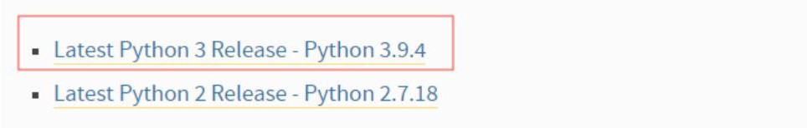

1. Double-click the executable file, which is downloaded; the following window will open. Click on the Add Path check box, it will set the Python path automatically.

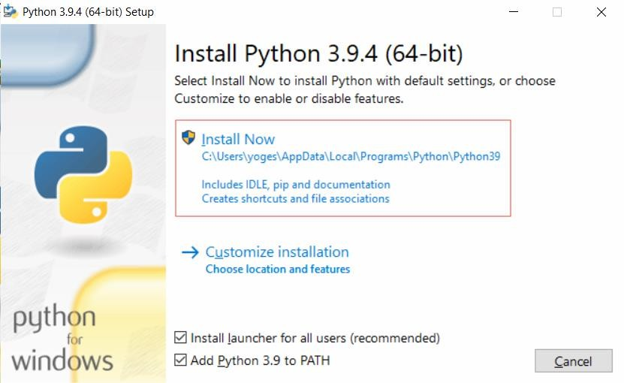

1. Run the Python Installer once downloaded. (In this example, we have downloaded Python 3.9.4)
2. Make sure you select the “Install launcher for all users” and “Add Python 3.9 to PATH” checkboxes.
3. Select Install Now — the recommended installation options.
4. Wait for it to complete the installation process

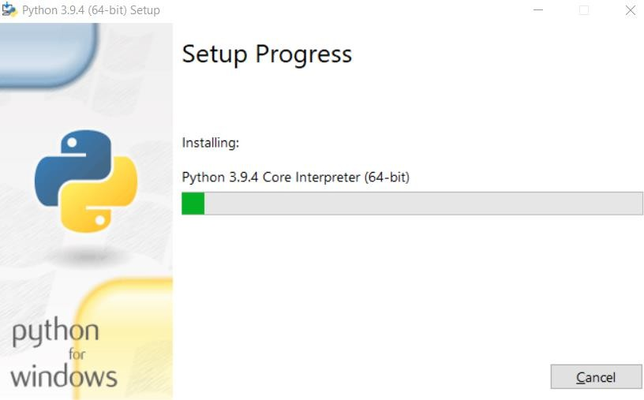

1. The next dialog will prompt you to select whether to Disable the path length limit. Choosing this option will allow Python to bypass the 260-character MAX_PATH limit. Effectively, it will enable Python to use long path names.

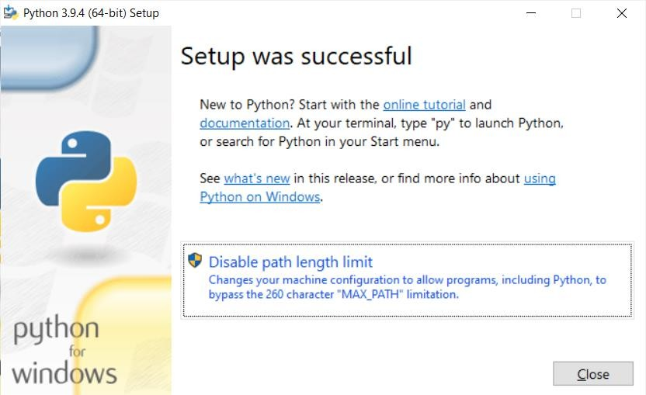

1. To check if Python 3.9.4 has been successfully installed in our system, open *cmd* prompt in your system and run *“Python -V”*
2. To open Python IDLE environment, open windows search, and type “IDLE” and open it.
3. From the “File” menu, select “New file” and create a new blank python script file
4. Save the script file as “lab2_1.py” at appropriate location on the disk
5. Modify “lab2_1.py”
   1. Use two string variables named “first_name” and “last_name”. Assign values (first_name=”Ali”, last_name=”Khan”) to them and then print the names on the screen using “print” function. The output should be like the following.

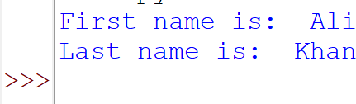

* 1. Modify the program to join first name and last name and show them on one line, like the following



* 1. Use *input()*function to ask the user the first name and last name and then display on the output. The output should be similar to the following:

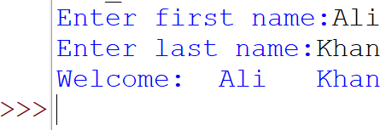

* 1. Further modify the program to find and display the length of the name entered by the user. Use *len()* to find the length of the names and then display using *print()* function. Your output should match the follwing:

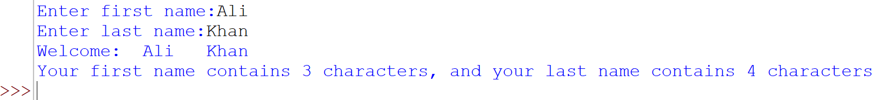

* 1. Modify the program to show the user entered name in small, capital and title case.

1. Write a program “lab2_2.py” that inputs two numbers and shows the results of addition, subtraction, multiplication, and division operations on both numbers. The output should match the following:

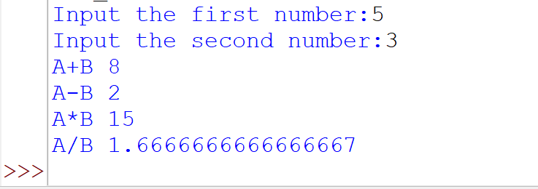

1. Write a program “lab2_3.py” that takes an input from the user and tells its type. Use *type()* function.

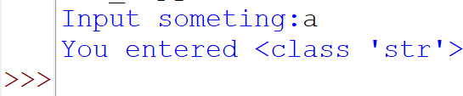

1. Write a program “lab2_4.py” to learn about typecasting i.e., setting specific data types (str(), float(), int()).

# QUESTIONS:

Q # 1: Consider the following code snippet in Python?

a = 1.0

b = "1"

c = "1.1"

Now, write the output of the following lines

1. a + float(b)
2. float(b) + float(c)
3. a + int(c)
4. a + int(float(c))
5. int(a) + int(float(c))
6. 2.0 * b

Ans.

1. 2.0

2. 2.1

3. 2.0

4. 2.0

5. 2

6. 2.0

Q # 2: What would be the output of the following Python code? a)

a,b='red','blue' a,b=b,a print(a,b)

blue red

b)

a='10'

print(a+a)

1010

str = 'Hello World!'

print (str) print (str[0])

print (str[2:5])

print (str[2:]) print (str * 2) print (str + "TEST")

hello world!

h

llo

llo world!

hello world!hello world!hello world!

hello world!TEST

**Name: Huzaifa**

**Roll #: 23-Ai-21**

**Date: 20-12-21**

**Subject Teacher**

**Remarks:**

**Q12. Modify Lab2_1.py:**

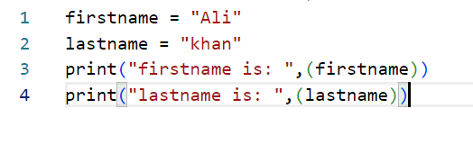

**A.**

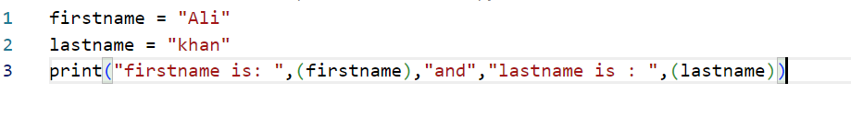

**B.**

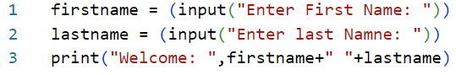**C.**

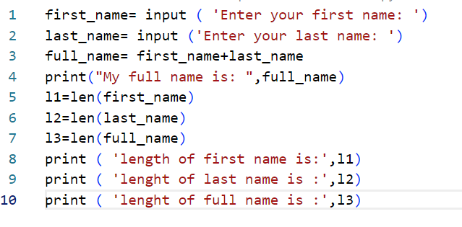

**D.**

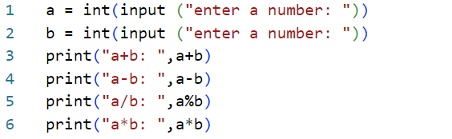**E.**

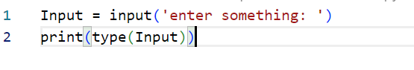**Q14.**

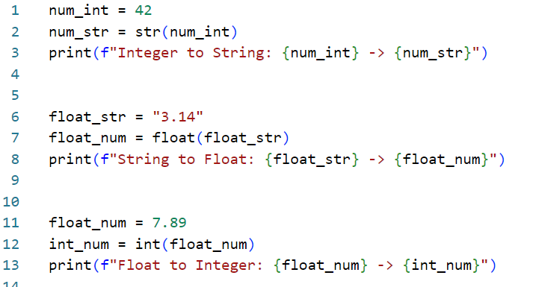**Q15.**